Please submit abstracts using the attached abstract submission form and format as follows:
Mark-Recapture Sampling to Assess Populations of the Endangered James Spinymussel (Pluerobema collina)
B. T. Watson*¹, B. J. K. Ostby², T. E. Dickinson³
*Presenting Author
¹Virginia Department of Game & Inland Fisheries, Forest, VA
²Daguna Consulting, LLC, Abingdon, VA
³The Catena Group, Hillsborough, NC
Abstract (300 words or less):
Determining the viability of freshwater mussel populations is necessary in developing and implementing conservation plans. However, data regarding population sizes and parameters such as survival and recruitment are lacking. Mark-recapture sampling allows for estimation of these parameters, while also accounting for variable detection probabilities. The federally endangered James spinymussel (Pluerobema collina) is predominately found in the James River Basin in Virginia and West Virginia and a significant population was discovered in Little Oregon Creek, Craig County, VA, in 2010, allowing for mark-recapture sampling. Population estimates in 2010 using program MARK and CAPTURE ranged from 1,769 – 1,909, with quadrat estimates not significantly different. Detection probabilities varied by section and date from 10% – 30% and were similar to those determined from quadrat sampling. Sampling will continue through 2015 in Little Oregon Creek and at six additional locations.
Type: Oral presentation
Eligible for Best Student Paper or Poster Award? No
Primary contact for this submission:
Name: Brian Watson
Email: bwatson@randomemail.com
Phone: 555-555-5555

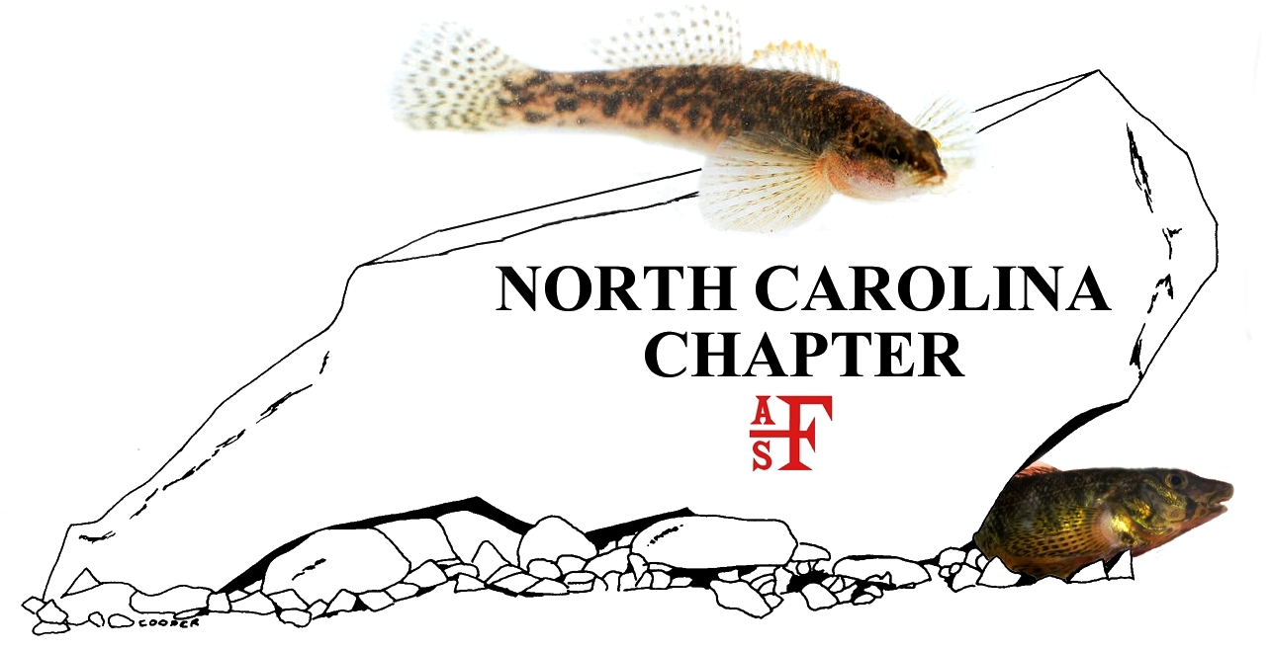
2017 Meeting Abstract Submission Form
Click here to enter presentation or poster title.
Click here to enter authors. Use superscript to link to affiliation below. Indicate presenter with asterisk.
*Presenting
Click here to enter author affiliation. Use superscript to link to author name above. Include author organization name, city, and state.
Abstract (300 words or less):
Click here to enter abstract.
Type: Click here to enter ‘Poster’ or ‘Oral presentation’.
Is the presenter a Student or a Professional? Click here to enter ‘Student’ or ‘Professional’.
Primary contact for this submission:
Name: Click here to enter contact name.
Email: Click here to enter contact email.
Phone: Click here to enter contact phone, xxx-xxx-xxxx.

