[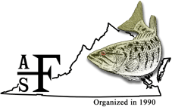](http://sdafs.org/vcafs/)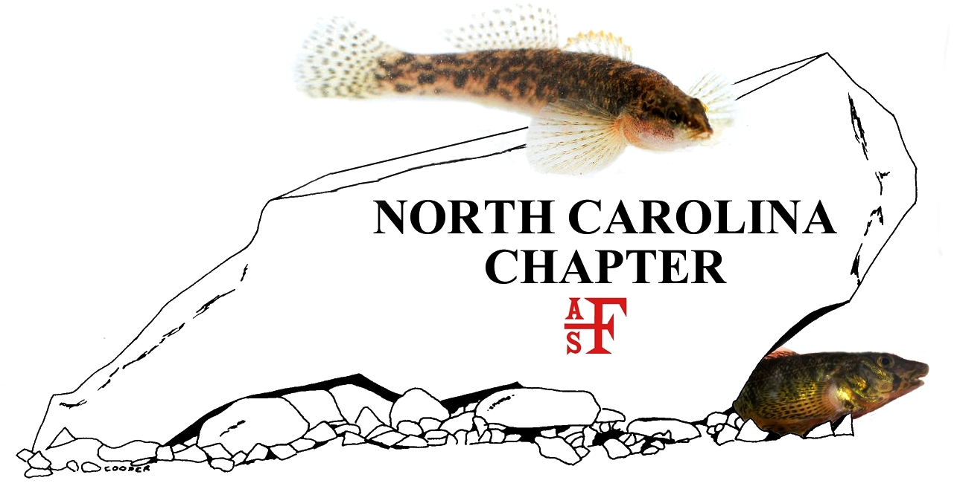

***Announcement and Call for papers***

**2016 Meeting of the Virginia and North Carolina Chapters**

**of the American Fisheries Society**

Tuesday, March 15th to Thursday, March 17th, 2016

[Institute for Advanced Learning and Research](https://www.google.com/maps/place/Institute+for+Advanced+Learning+and+Research/@36.5787266,-79.3573176,15z/data=!4m2!3m1!1s0x0:0x15d7c8d1f9138c6a)

[Danville, Virginia](https://www.google.com/maps/place/Institute+for+Advanced+Learning+and+Research/@36.5787266,-79.3573176,15z/data=!4m2!3m1!1s0x0:0x15d7c8d1f9138c6a)

In keeping with recent meetings, a continuing education workshop (Conservation Genetics) will be held on Tuesday afternoon, March 15th. There will be oral and poster presentations and separate Virginia and North Carolina Chapter business meetings on March 17th. Final presentations will be on the afternoon of March 17th. Since we will be on the Dan River, scene of a major coal ash spill in 2014, we are organizing a symposium on impacts and ongoing assessment and recovery actions.

How to submit an abstract: Complete the attached abstract submission form. Attach the abstract submission form to an email with the subject line “Joint AFS Meeting 2016 Abstract”. Email the form to both VA Chapter Program Committee Chair Craig Roghair at [croghair@fs.fed.us](mailto:croghair@fs.fed.us) and to NC Program Committee Chair Mike Gangloff at [gangloffmm@appstate.edu](mailto:gangloffmm@appstate.edu).

New this year, Lightning talks: 5 minute talk, 3 minute question/answer, PowerPoint optional; for students and professionals to present new projects or programs, results from ongoing work, emerging issues, and other research or management briefs. To participate, complete the submission form and enter “Lighting talk” in the *Type* box.

Important dates: Submit your abstract by January 15, 2016. Authors will be notified of abstract receipt and acceptance by January 31, 2016. Abstracts submitted after the deadline may be presented as a poster.

Program Committee: Mike Gangloff (NC Chair), Craig Roghair (VA Chair), Aaron Bunch, Andy Dolloff, Eric Hallerman, Bud LaRoche, Michael Moore, Michael Perkins, and Bryn Tracy.

***Please submit abstracts using the attached abstract submission form and format as follows:***

Mark-Recapture Sampling to Assess Populations of the Endangered James Spinymussel (*Pluerobema collina)*

B. T. Watson*1, B. J. K. Ostby2, T. E. Dickinson3

*Presenting Author

1Virginia Department of Game & Inland Fisheries, Forest, VA

2Daguna Consulting, LLC, Abingdon, VA

3The Catena Group, Hillsborough, NC

**Abstract (300 words or less):**

Determining the viability of freshwater mussel populations is necessary in developing and implementing conservation plans. However, data regarding population sizes and parameters such as survival and recruitment are lacking. Mark-recapture sampling allows for estimation of these parameters, while also accounting for variable detection probabilities. The federally endangered James spinymussel (Pluerobema collina) is predominately found in the James River Basin in Virginia and West Virginia and a significant population was discovered in Little Oregon Creek, Craig County, VA, in 2010, allowing for mark-recapture sampling. Population estimates in 2010 using program MARK and CAPTURE ranged from 1,769 – 1,909, with quadrat estimates not significantly different. Detection probabilities varied by section and date from 10% – 30% and were similar to those determined from quadrat sampling. Sampling will continue through 2015 in Little Oregon Creek and at six additional locations.

**Type:** Oral presentation

**Is the presenter a Student or a Professional?** Professional

**Primary contact for this submission:**

**Name:** Brian Watson

**Email:** bwatson@randomemail.com

**Phone:** 555-555-5555



**2016 Meeting Abstract Submission Form**

Click here to enter presentation or poster title.

Click here to enter authors. Use superscript to link to affiliation below. Indicate presenter with asterisk.

*Presenting

Click here to enter author affiliation. Use superscript to link to author name above. Include author organization name, city, and state.

**Abstract (300 words or less):**

Click here to enter abstract.

**Type:** Click here to enter ‘Poster’, ‘Oral presentation’, or ‘Lightning talk’.

**Is the presenter a Student or a Professional?** Click here to enter ‘Student’ or ‘Professional’.

**Primary contact for this submission:**

**Name:** Click here to enter contact name.

**Email:** Click here to enter contact email.

**Phone:** Click here to enter contact phone, xxx-xxx-xxxx.