Please submit abstracts using the attached abstract submission form (pg 2) and format as follows:
Population Augmentation and Monitoring of the Tar River Spinymussel
Tom R. Fox*¹, Tyler. R. Black¹, Rachael A. Hoch²
*Presenting Author
¹North Carolina Wildlife Resources Commission, Aquatic Wildlife Diversity Program, Mebane, NC
²North Carolina Wildlife Resources Commission, Division of Inland Fisheries, Marion, NC

Abstract (300 words or less):
The Tar River Spinymussel (Elliptio steinstansana) is a highly imperiled federally endangered species restricted to the Tar and Neuse river basins in North Carolina. Beginning in 2007, the North Carolina Wildlife Resources Commission (NCWRC) partnered with the U.S. Fish and Wildlife Service and North Carolina State University to collect broodstock, propagate Tar River Spinymussels, and ultimately augment remaining populations. Between December 2014 and September 2016, NCWRC and partners released over 9,500 propagated Tar River Spinymussels at four locations in Fishing and Little Fishing creeks (Tar River basin). From December 2014 to October of 2015, 1310 Tar River Spinymussels, were individually tagged, measured, and released into an experimental reach of Little Fishing Creek. In August 2015 and August 2016, a two pass snorkel survey was conducted in the experimental stocking reach to evaluate the success of the initial augmentations, 35% and 20% of the released mussels were recaptured as live individuals, respectively. Mean growth of recaptured individuals was 1.04 mm (SD=0.7mm). Preliminary results suggest that stocking propagated individuals of the Tar River Spinymussel into the best available habitat has the potential to bolster dwindling populations and assist in the recovery of this species.
Type: Full presentation
Is the presenter a Student or a Professional? Professional

Primary contact for this submission:
Name: Tom Fox
Email: tfox@randomemail.com
Phone: 555-555-5555

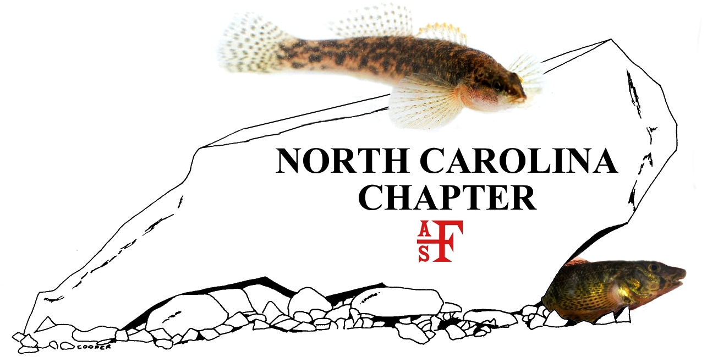
2018 Meeting Abstract Submission Form
Click here to enter presentation title.
Click here to enter authors. Use superscript to link to affiliation below. Indicate presenter with asterisk.
*Presenting
Click here to enter author affiliation. Use superscript to link to author name above. Include author organization name, city, and state.
Abstract (300 words or less):
Click here to enter abstract.
Type: Click here to enter ‘Full Presentation’ or ‘Lightning Talk’.
Is the presenter a Student or a Professional? Click here to enter ‘Student’ or ‘Professional’.
Primary contact for this submission:
Name: Click here to enter contact name.
Email: Click here to enter contact email.
Phone: Click here to enter contact phone, xxx-xxx-xxxx.

