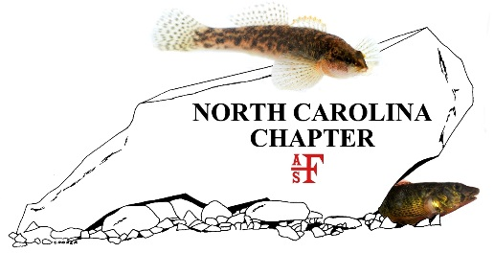

North Carolina Chapter of the American Fisheries Society
Business Meeting
June 2, 2022

- Determination of Quorum, Casey Joubert, Secretary/Treasurer

- Call to Order, Ryan Heise, President

- Welcome and Introductions, Ryan Heise, President
  - AFS Parent Society EXCOM in attendance
  - AFS Past President(s) in attendance
  - AFS Southern Division and Past-President(s) in attendance
  - NC AFS Past-Presidents in attendance

- February 2021 Business Meeting Minutes

- Student Subunit Reports

- Committee Reports
  - Program and Arrangements – Andrea Leslie
  - Awards Committee – Greg Cope and Corey Oakley
  - Communications Committee – Kyle Rachels
  - Webmaster – Brena Jones
  - Education and Outreach Committee – Seth Mycko
  - Finance Committee – Casey Joubert
  - Nominations Committee – Ben Ricks
  - Mentoring Committee – Kevin Dockendorf

- Awards Presentations

- 2025 SD AFS Meeting

- New Business

- Installation of Newly Elected Officers

- Winner of AFS Membership

- Remarks by Incoming President

- Adjourn

